**How to run Batch HMM classification**

The HMM is vbSPT and I always use a 2-state version: <http://vbspt.sourceforge.net/>

Everything is in this folder: /Users/anderssejrhansen/Dropbox/Shared_with_Assaf/AndersScripts/HMM_classification

Please open the script “Batch_vbSPT_classify.m” and press run. Everything should run on the example data and expect it to take around 5 min to finish.

The script reads in the frame rate from the file name. E.g. “20171023_sim_mESC_C45_mRad21-Halo_G1_133Hz_pooled_QC_CD2.mat”. So please make sure you name your simulations either 223Hz, 133Hz or 74Hz.

Here is what the batch script does:

* It first reads in SPT data in my own preferred format. In “TestData”, I put 2 example SPT files (.mat format). They should contain a structured array called “trackedPar_QC”. Please use this format:

The MAT-files contain a [structure array](https://www.mathworks.com/help/matlab/ref/struct.html) named “trackedPar_QC”. trackedPar_QC contains three variables:

* trackedPar_QC.xy: “xy” is a matrix with 2 columns and a number of rows corresponding to the number of localizations in that trajectory. The first column is the x-coordinate and the second column is the y-coordinate. The units are micrometers (μm).
* trackedPar.Frame_QC: “Frame” is a column vector where each element is the frame where the particle was localized.
* trackedPar.TimeStamp_QC: “TimeStamp” is a column vector where each element is the timepoint where the particle was localized.

Each element in the structure array “trackedPar_QC” correspond to a different trajectory as illustrated below:

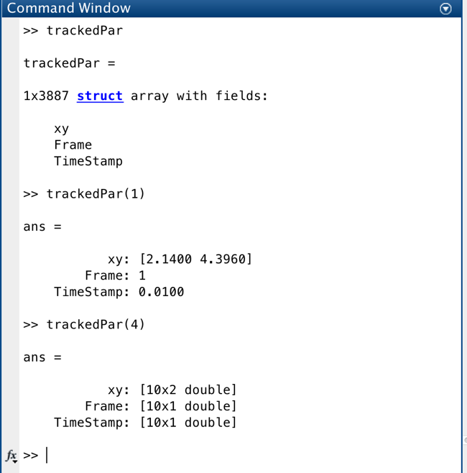

* Once it has read in the data, the data gets converted to a cell array format preferred by vbSPT and saved in the folder “QC_data_reformatted”
* Now it’s ready to do the HMM classification. vbSPT annoyingly reads a file called “vbSPT_RunInputFileBatch.m”. So I custom wrote a script to edit these files and copy them to the folder “FolderWithRunInputFiles”. As long as you keep the format consistent, you should not need to deal with this.
* It will then perform HMM-classification (about 2-3 min per file) and save the HMM-classificed data in “QC_HMM_classified_data”.
* The final MAT-file contains: “CellTracks”, a cell-array of x-y coordinates and “CellTracksViterbiClass”, the HMM-classification with 1 for bound and 2 for free.